Project Title



AGRICULTURE RAW MATERIAL

analysis AI system

**Name & Email id** :CHANDHRU K[&](mailto:&)**chandhru936**[**@gmail.com.**](mailto:balamuruganmaran333@gmail.com)

**NM I'D :** au921821114003.

**Guide** : (P.Raja, Master Trainer ).

Disclaimer: The content is curated for educational purposes only.

# OUTLINE



* Abstract of the Project
* Problem Statement
* Proposed Solution
* System Architecture
* Live Demo of the Project
* Embedded Video of Project
* Conclusion
* Future Scope

# Abstract

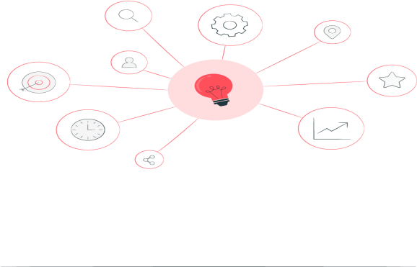

This project systematically analyzes agricultural raw materials—seeds, fertilizers, and pesticides—to enhance supply chain efficiency and improve product quality. Through field studies and lab testing, we assess their physical, chemical, and biological properties and their impacts on crop yield and soil health. Collaborating with farmers and industry stakeholders, we aim to develop best practices for sustainable use of high-quality inputs. Findings will inform future research and policies, promoting food security and minimizing environmental impact.

# Problem Statement



The agricultural sector struggles with sourcing and maintaining high-quality raw materials due to climate change, soil degradation, market volatility, and evolving consumer demands. These challenges create variability in input quality and disrupt supply chains. This project conducts a comprehensive analysis of agricultural raw materials to understand their current status, improve sustainability practices, and aid decision-making for farmers and stakeholders. The study addresses critical issues, including quality variability, supply chain disruptions, and environmental sustainability, to support a resilient and sustainable agricultural sector.



# Proposed Solution



## Implement Advanced Technology for Efficient Harvesting :

Use precision farming tools, drones, and IoT-based sensors to optimize raw material collection, reduce waste, and increase overall efficiency in gathering crops and other agricultural products.

## Enhance Supply Chain Infrastructure :

Develop better storage, transportation, and processing facilities to minimize spoilage and ensure

timely delivery of raw materials, while also supporting sustainability and reducing carbon footprints.

## Promote Sustainable Farming Practices :

Encourage farmers to adopt sustainable and regenerative agricultural methods that increase yield, reduce environmental impact, and ensure a steady, long-term supply of raw materials.

# System Architecture



## Data Collection Layer :

Sensors, drones, and IoT devices collect real-time data from fields (soil moisture, crop health, weather conditions) to monitor crop growth and determine the optimal time for harvest.

## Processing and Analysis Layer :

Data is sent to cloud-based platforms or local servers where AI and machine learning algorithms analyze the information, providing insights on crop readiness, yield predictions, and

resource optimization.

## Logistics and Supply Chain Management Layer :

The optimized collection plan is sent to automated harvesting equipment and logistics systems, which ensure raw materials are efficiently harvested, sorted, stored, and transported to processing units or distribution centers.

# Live Demo of Project



## Real-Time Data Monitoring :

Showcase live tracking of field conditions using sensors, drones, and IoT devices that collect data on soil moisture, weather, and crop health. This data helps determine the best time for harvest.

## AI-Powered Crop Analysis :

Demonstrate the use of AI algorithms that process the collected data to assess crop readiness, predict yield, and identify areas requiring attention or optimization for harvesting.

## Automated Harvesting :

Show how autonomous harvesting machines or robotic systems collect raw materials based on real-time data, ensuring high precision, minimal waste, and faster processing times.

## Smart Logistics Coordination :

Highlight the real-time management of logistics for transporting the harvested materials from the field to storage or processing units using GPS-enabled systems and automated vehicles.

## Supply Chain Optimization Dashboard :

Present a live dashboard that tracks the entire raw material collection and distribution process, from harvesting to storage and delivery, ensuring efficiency, transparency, and timely operations.

# Live Demo Of The Project



Project Title



# Video of Project Demo

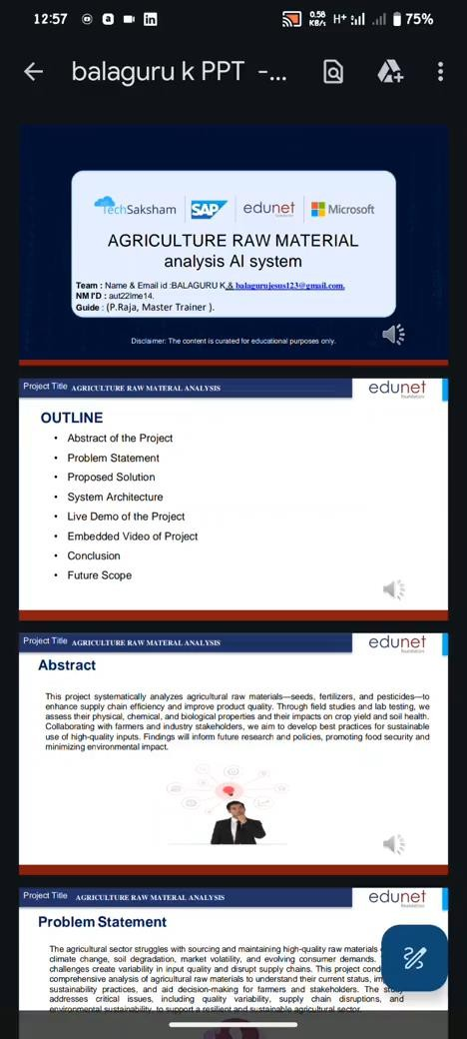

**Conclusion**



Understanding the prices of raw materials like Coarse wool, Cotton, Rubber, and Wood can aid in cost-effective business planning and budget allocation. Analyzing these prices allows us to forecast future costs, helping businesses decide which crops or materials to invest in. By studying historical price trends, businesses can better prepare for seasonal demands, like increased cotton needs in summer or rubber demand during rainy seasons. Each material's unique demand and supply factors, such as seasonal variations and market shifts, influence pricing. This analysis helps businesses optimize procurement and production strategies, ensuring stable raw material supply year-round.



# Future Scope



1. **Data Compilation:** Gather comprehensive data on agricultural raw materials, including seeds, fertilizers, and pesticides.
2. **Quality Assessment**: Evaluate the physical, chemical, and biological properties of collected materials.
3. **Supply Chain Analysis:** Identify sourcing challenges and improve the efficiency of material distribution.
4. **Sustainability Review:** Analyze materials for environmental impact, promoting eco-friendly alternatives.
5. **Market Insight:** Monitor price trends and demand shifts to aid in future procurement and production planning.





**Thank you!**